**Project Development Phase**

**Sprint 3**

|  |  |
| --- | --- |
| Date | 12 November 2022 |
| Team ID | PNT2022TMID41225 |
| Project Name | Global Sales Data Analytics |

**Sprint 3 tasks:**

* Creating Dashboard

**Sales By sub category and sales by region:**

Visualization represents the sales by sub category and sales by region.

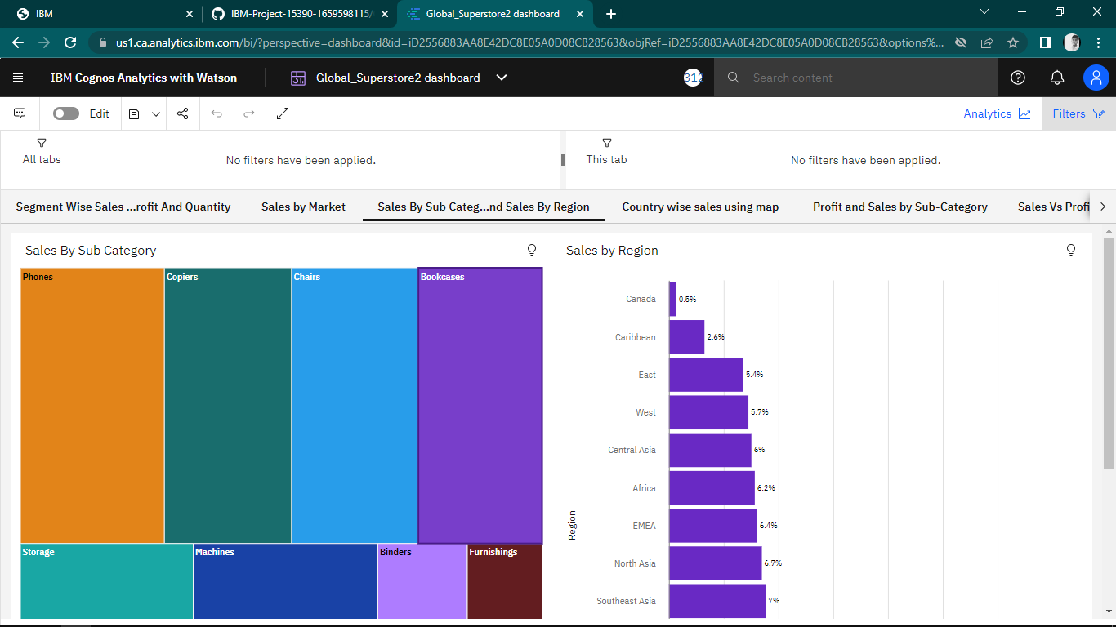

**Country wise sales using map points:**

Geo maps provides insights of sales by country.

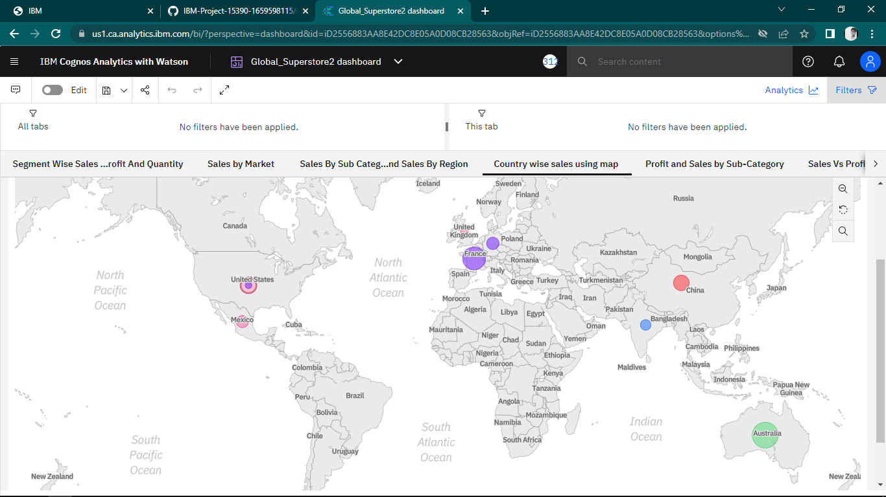

**Sub Category Wise Sales And Profits Using Line And Bar Chart:**

Sales vs Profit are represented in the below combinational visualization - Bar represents the sales by sub-Category and the Line represents the Profit by Sub-Category. Sub Category Wise Sales and Profits using Line and Bar Chart.

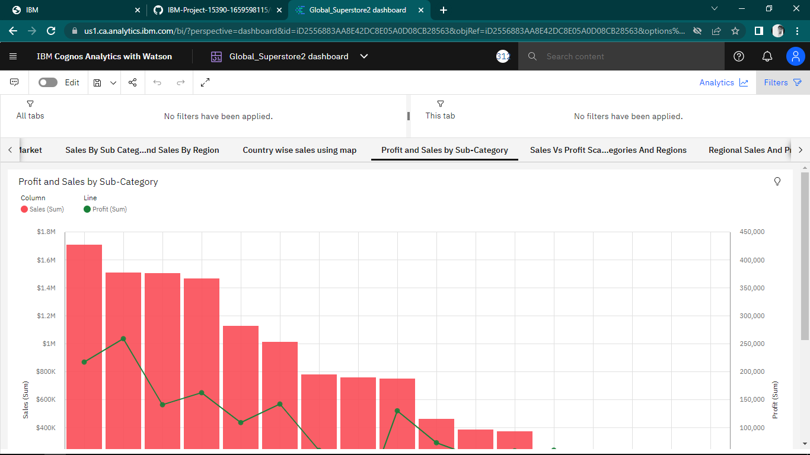

**Sales Vs Profit Scatter Plot with Sub Categories and Regions:**

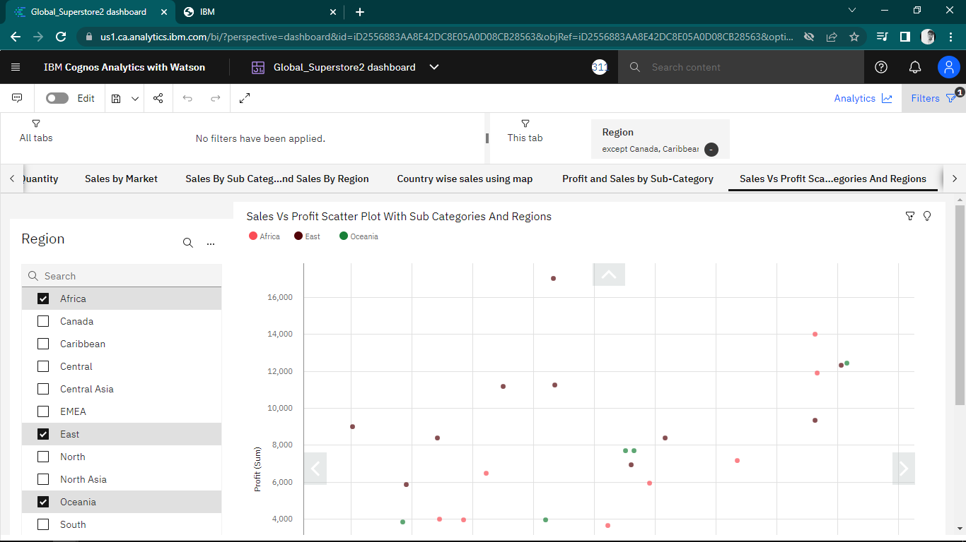

**Regional Sales and Profit Forecast:**

Monthly Sales vs Profit forecast Analysis is represented in the below visualizations.  It shows the Monthly Sales and Profits by Regions. Regional Sales and Profit Forecast.

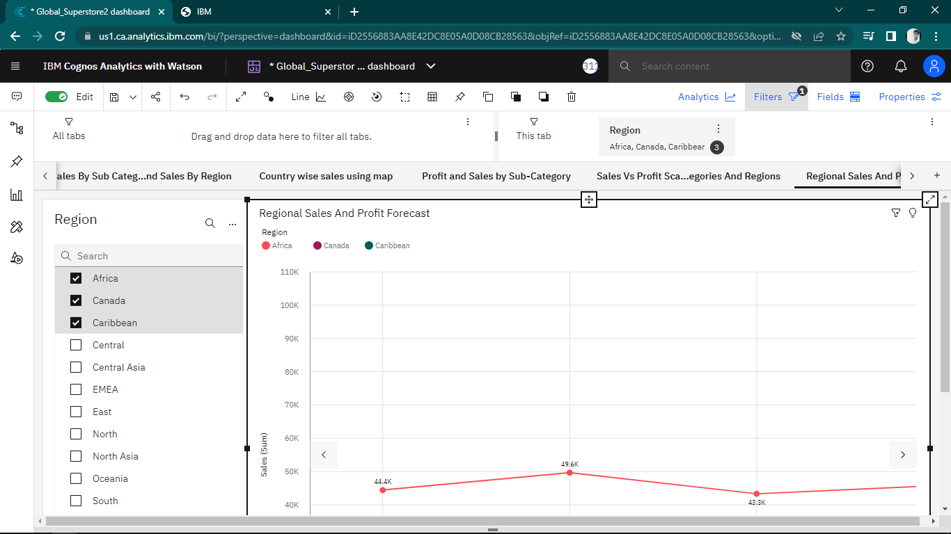

**Sales Forecast by Order Priority:**

Monthly Sales forecast is presented in the below visualization based on the Sales Order Priority.

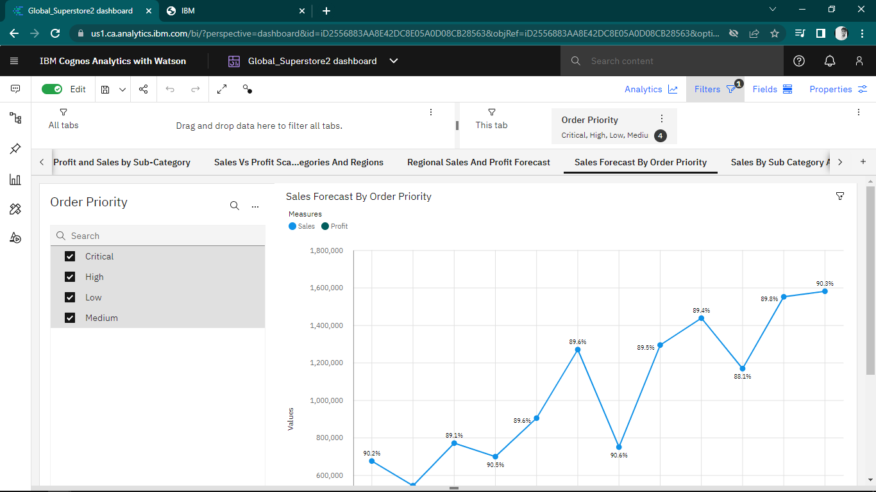

**Sales by Sub Category Analytics:**

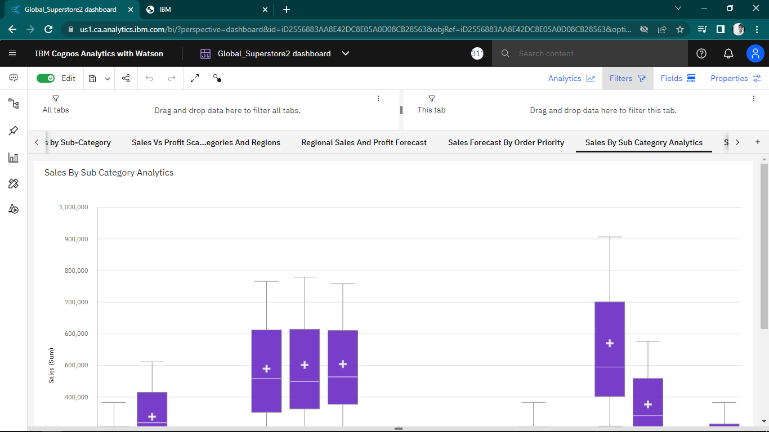

**Sales by Segment Analysis:**

The following Analytical Visualization - Bullet Chart, shows the Mean, Median, Min and Max Sales by Segment along with Targeted Sales values.

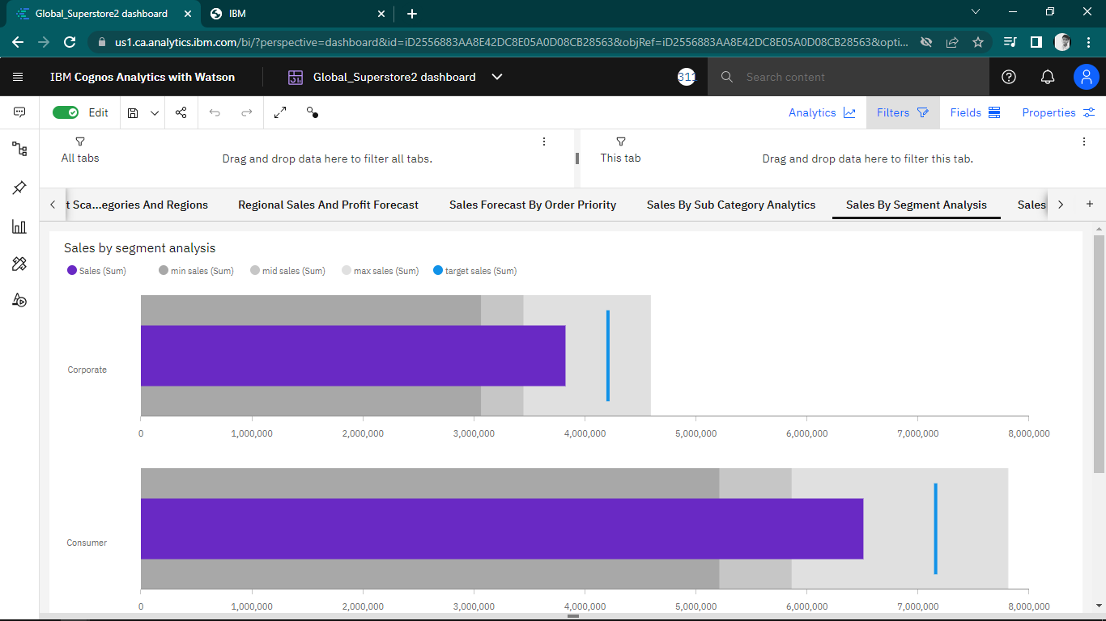

**Sales Vs Profit By Countries:**

The following visualization represents Sales vs Profit by Countries.

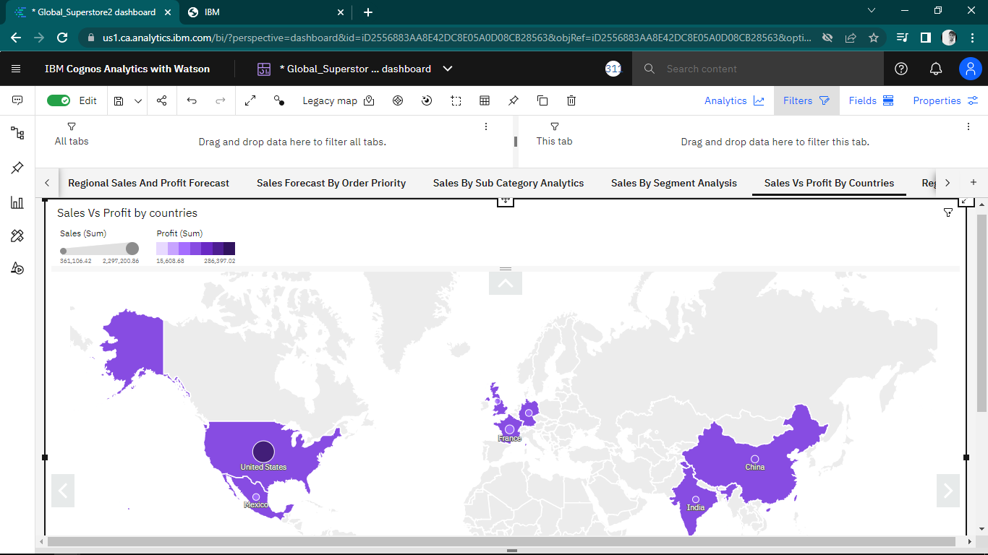

**Regional Quantity and Sales Using Radar Chart:**

The below Radar Visualization represents Regional Quantity and Sales.

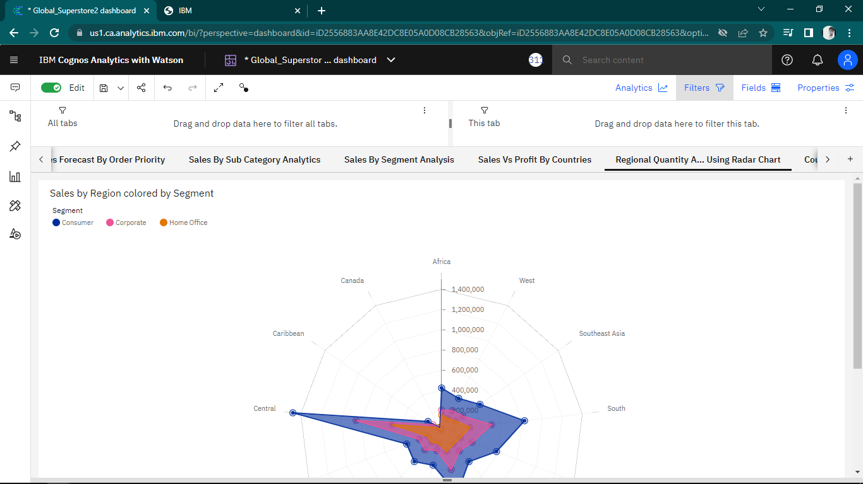

**Country Wise Sales vs Profit Using Word Cloud:**

The following visualization represents Country Wise Sales vs Profit using Word Cloud.

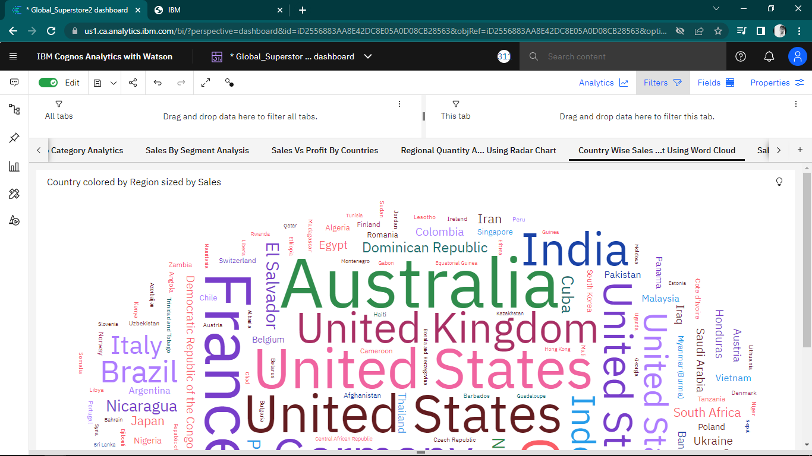

**Sales Dashboard:**

The following Sales Dashboard represents various analytical visualizations for overall compartive study of Sales Business of the organization.

